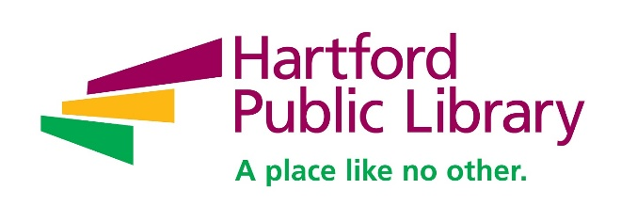

**Contact: Andy Hart**

**Hartford Public Library**

**860-695-6282**

**ahart@hplct.org**

**Hartford Public Library Announces 2019 Line-up for Baby Grand Jazz Series**

***Ray Gonzalez to Open Series with Special Three Kings Day Performance***

**(HARTFORD, CT, December 4, 2018)** Hartford Public Library (HPL) will blow away the post-holiday blues as the highly-popular Baby Grand Jazz Series returns for its 16th season starting Sunday, January 6. Baby Grand Jazz performances will be held every Sunday this year through April 28, with the exception of Easter (April 21), from 3 – 4 pm (doors open at 2 pm).

The opening show will be a special Three Kings Day performance by local salsa and Latin jazz master Ray Gonzalez and his quartet. The show will be held in the atrium of the Downtown Library, 500 Main Street, Hartford. All other shows will be held in the Downtown Library’s Center for Contemporary Culture (Main Floor) with the exception of the final show, Giacomo Gates, on April 28.

2019 Baby Grand Jazz Schedule:

Ray Gonzalez, January 6

Simona Premazzi Quartet "DreamTeam", January 13  
Emery Austin Smith and Orice Jenkins, January 20  
Sound Reformation, January 27

Sam Newsome Quartet, February 3  
Sarah Hanahan Quintet, February 10  
Presidents' Day Nick Di Maria Quintet, February 17  
Leala Cyr Group, February 24

Brian Charette, March 3  
The Carl Bartlett, Jr. Quartet, March 10  
Orice Jenkins presents: Centennial Nat King Cole, March 17  
Mary DiPaola Trio, March 24  
KingPorter BAM BAND, March 31

Firey String Sistas! April 7  
Matt Dwonszyk and the Dwonztet, April 14  
Giacomo Gates, April 28

Admission to all Baby Grand Jazz series performances is free thanks to the generous financial support of The Kaman Foundation. The library’s partners in the series also include the Hartford Jazz Society and WWUH 91.3 FM Radio.

For a full-line of this year’s Baby Grand Jazz Series and descriptions of the performers, go to: <https://www.hplct.org/classes-seminars-exhibits/baby-grand-jazz>.

**ABOUT HARTFORD PUBLIC LIBRARY**

Now celebrating its 125th year, Hartford Public Library remains at the forefront of redefining the urban library experience in the 21st Century. With seven locations throughout the city, the library provides education, intellectual enrichment and cultural development for thousands of children, youth and adults every year. Hartford Public Library has also gained local and national recognition for its wide range of new initiatives and partnerships designed to meet the needs of a diverse and dynamic city and region, including immigration services, employment assistance and youth leadership training. Please visit www.hplct.org.