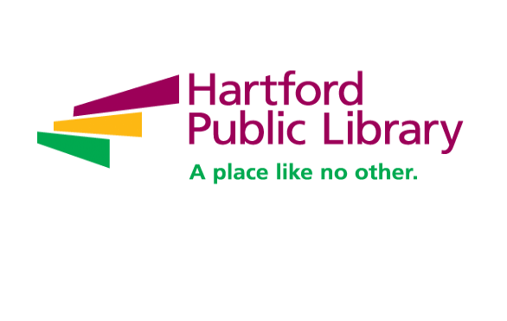

**Communications and Marketing Associate Full Time**

Under the supervision of the Communications and Marketing Director, the Communications & Marketing Associate will help promote the Library's mission, programs and services and assist in execution of the Library's communications efforts in accordance with the Library's Strategic Plan. As a part of the communications department this role will help manage the universal messaging for Hartford Public Library (HPL). The associate will develop written and graphic content to be displayed across a wide variety of platforms including social media and the HPL website and will share HPL messaging at community events and library functions. This role requires a self-starter with familiarity of social media platforms and trends; the ability to juggle multiple tasks and to prioritize work based on the needs of the organization. Strong writing and copyediting skills and in person communication skills are a must; with experience in photography, video, and graphic design. This is an exciting opportunity as HPL continues to grow and evolve and its capacity to serve the Hartford community.

**ESSENTIAL DUTIES AND RESPONSIBILITIES INCLUDE:**

**Content Creation**

* Produces written, photographic and video content to promote the library's mission, programs and services to internal and external audiences on multiple platforms.
* Assists in development of communication marketing materials for use in digital and print advertisements. To included but not limited to, copy editing, mailings, email marketing, social media marketing and other library publications including annual reports.
* Reviews departmental institutional submissions before released, and making sure all systems are up to date and information is displayed in a timely manner.
* Works with Programming Department to ensures Hartford Public Library events and services are regularly featured in community calendars and listings.
* Works in concert with the IT team to manage content on institutional webpages. Makes regular updates to HPL website to ensure information is accurate and timely.
* Assists Communications and Marketing Director with developing and implementing PR strategies and press opportunities, including press releases, news conferences and quarterly talking points.
* Escalates issues and flags potential concerns bringing them to the attention of the Communications and Marketing Director and ensures timely responses.

**Content Dissemination**

* Shares Hartford Public Library messaging and current talking points at community events and library functions, serving as a conduit delivering the most up-to-date and accurate information about the library, its programs, events and classes.
* Positively reflects Hartford Public Library's mission, vision and values to staff and the public.
* Helps to develop departmental structure that allows communications to create a cohesive and unified communications plan.
* Works with local vendors and contractors, creating and implementing contracts.

**Administrative Oversight**

* Assists in management of contractual service providers in Communications Department

**Other Duties**

* The duties listed above are intended only as illustrative of the various types of work that may be performed. The omission of specific statements of duties does not exclude them from the position if the work is similar or a logical assignment to the position.
* Must be available for occasional after hours HPL events and functions. Some nights and weekends will be required.

**EDUCATION and EXPERIENCE/QUALIFICATIONS**

**Qualifications Required:**

* Associate's degree required, preferably in communications, marketing, graphic arts or other closely related field.
* Minimum two years previous communications experience.
* Excellent written and verbal communications skills.
* Must be highly dependable, organized, focused and able to manage multiple tasks with attention to detail.
* Prior experience with social media marketing.
* Writing samples are required.

**Preferred:**

* Bachelor's degree
* Video/audio editing/production experience
* Knowledge of AP style
* Spanish speaking/writing skills

**PHYSICAL DEMANDS / WORK ENVIRONMENT**

* Ability to continuously bend, twist, stoop, reach and pull.
* Ability to keep composure in everyday, potentially stressful situations
* Ability to meet a flexible work schedule, including evenings and weekends.
* Able to walk, sit and stand for extended periods
* Close vision, distance vision, peripheral vision, depth perception and the ability to adjust focus.
* Access to transportation, ability to travel to different work sights.

**What we offer employees:**

Hartford Public Library offers robust benefits you won’t find at other nonprofit organizations through a unique partnership with the City of Hartford. This includes:

* MERF Pension Plan with employer contribution
* Health Care, Dental, Pharmacy benefits
* Life Insurance
* Long Term Disability Insurance
* Mental health support through the Employee Assistance Program
* Tuition reimbursement program
* Paid professional development, continuing education and staff engagement opportunities
* Commitment to, and active plan of, diversity, equity, and inclusion work including implementation of the staff-led DEI Road Map.

**What we offer the community:**

The Hartford Public Library is a national leader in redefining urban public libraries in the 21st century as innovative, stimulating and engaging spaces where people can learn and discover, explore their passions and find a rich array of resources that contribute to a full life.

We are an integral part of the Hartford community and offer programs for all our citizens. With 7 locations and robust outreach services, we are here for Hartford. Our programs include:

* The American Place, which offers a variety of free services to welcome immigrants and refugees including English Language Learning, Citizenship preparation and civic engagement
* Digital Library Lab
* Hartford History Center
* HPL Studios
* YOUmedia teen spaces
* Baby Grand Jazz, a free series of Jazz performances open to everyone
* Summer Learning
* Leap into Learning - Early Literacy
* Adult education classes and support
* Career Certification, GED
* Technology training and digital literacy
* Library of Things
* Robust print, electronic, audio and video collections · And so much more!

**To Apply:** Please email resume and cover letter to [hpljobs@hplct.org](mailto:hpljobs@hplct.org) and reference **Communications and Marketing Associate** in the subject line of your email.

In light of the ongoing COVID-19 pandemic, the Hartford Public Library strongly recommends and encourages all newly hired employees to receive vaccinations. Vaccinations have proven to be an effective measure in preventing the spread of the virus and protecting individuals from severe illness. We are committed to safeguarding our workplace and community. While COVID-19 vaccinations are recommended, vaccinations are not required at this time.

**Hiring Range:** $57,876.84 - $60,851.44

**Hartford Public Library is an Equal Opportunity Employer.**