**ESL Podcasts**

✔ = basic level ✔✔ = intermediate level ✔✔✔ = advanced level = = iTunes available (click for link)

# [Voice of America](http://learningenglish.voanews.com/) ✔    

Listen and watch news stories on your computer or portable media device. Has accompanying lessons and grammar practice for basic and intermediate levels.

**[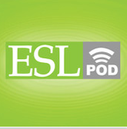](http://www.eslpod.com/website/index_new.html)**[](https://itunes.apple.com/us/podcast/english-as-second-language/id75908431)[**ESL Podcast**](http://www.eslpod.com/website/index_new.html)  ✔✔✔  

Listen to podcasts on a variety of subjects to strengthen listening comprehension. Free membership. Has accompanying blog.

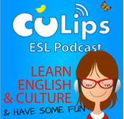[](https://itunes.apple.com/us/podcast/culips-esl-podcast/id279999557)[**Culip’s ESL Podcast**](http://tunein.com/radio/Culips-ESL-Podcast-p397057/)  ✔✔✔ 

Listen to natural English expressions and everyday vocabulary. Each episode has interesting element of culture as well as language. Intended for the advanced learner.

[](https://itunes.apple.com/us/podcast/english-as-second-language/id75908431)**[](http://www.esl-library.com/blog/category/podcasts/)**[**ESL-Library Podcasts**](http://www.esl-library.com/blog/category/podcasts/)  ✔✔    

Short podcasts on a wide variety of topics from U.S. historical events and issues to customs and holidays. Accompanying lessons available. For intermediate to advanced level students.

# [ELT Podcasts](http://www.eltpodcast.com/) ✔   

Theme-based conversations and language practice for basic and intermediate level learners. Dialogs have two or more speakers. Transcripts available.

[](https://itunes.apple.com/us/podcast/podcastsinenglish.com/id185436791)[**Podcasts in English**](http://www.podcastsinenglish.com/index.shtml) ✔   

Listen to podcasts to improve listening and speaking skills, including business and travel English. Podcasts available in all levels.

[](https://itunes.apple.com/us/podcast/american-english-pronunciation/id276921054)[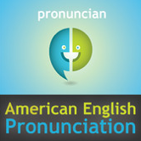**American English Pronunciation**](http://www.pronuncian.com/Podcast/Default.aspx?)  ✔✔

[](https://itunes.apple.com/us/podcast/storycorps/id609087377)[](http://storycorps.org/)Covers common and difficult English pronunciation. Learn the general American accent English speaking techniques and become better understood. Intermediate to advanced learners.

[**Story Corps**](http://storycorps.org/)  ✔✔✔

[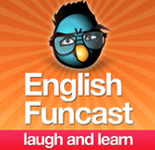](http://englishfuncast.com/)The largest oral history collection with more than 50,000 interviews from more than 80,000 participants. Intended for advanced learners.

[](https://itunes.apple.com/us/podcast/learn-english-funcast/id549042952)[**Learn English Funcast**](http://englishfuncast.com/)  ✔✔✔

[](https://itunes.apple.com/us/podcast/esl-aloud/id148731747?mt=2)Improve your English listening and speaking skills through humor. Learn how to understand and tell jokes. For advanced learners.

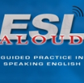[**ESL Aloud**](http://esl-aloud.com/)  ✔✔ 

Podcasts give guided practice in speaking English. Each podcast focuses on grammar and vocabulary buildings. Intended for intermediate to advanced learner.