**ESL Tablet Apps**

# [INTRO TO LETTERS, BY MONTESSOREUM](https://itunes.apple.com/us/app/intro-to-letters-by-montessorium/id387232375?mt=8)

# Appropriate for ESL children, this application runs through all the letters of the English alphabet, introducing them to the structure and pronunciation through tracing, audio, digital flashcards, and phonogram puzzles.

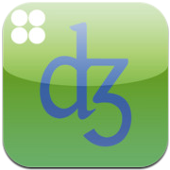[**SOUNDS RIGHT, BY BRITISH COUNCIL**](https://itunes.apple.com/us/app/sounds-right/id387588128?mt=8)

It’s a simple chart with great big resonance; when learning British English, refer to Sounds Right for proper pronunciation of vowels and diphthongs, with the former listed by mouth shape.

# SENTENCE BUILDER FOR IPAD, BY MOBILE EDUCATION TOOLS 

The winner of IEAR’s 2010 Language App of the Year distinction targets students and challenges them to construct simple, grammatically correct sentences around provided pictures and videos.

[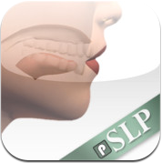](https://itunes.apple.com/us/app/speech-tutor/id424752543?mt=8)

[**SPEECH TUTOR, BY SYNAPSE APPS**](https://itunes.apple.com/us/app/speech-tutor/id424752543?mt=8)

Work on your accent or work on pronouncing specific letters with this incredibly detailed app. Features animations of the sides and fronts of mouths illustrating proper tongue and lip formations.

[**IDAILY PRO HD, BY FRONTIER ONE**](https://itunes.apple.com/us/app/idaily-pro-hd/id453217344?mt=8)

Frontier One’s innovative app turns English language news into valuable lessons in grammar and sentence structure with its super amazing custom dictionary allowing users to save words and phrases that need clarifying.

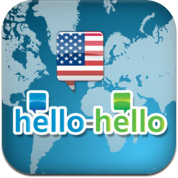[**HELLO-HELLO ENGLISH, BY HELLO-HELLO**](https://itunes.apple.com/us/app/hello-hello-english/id387137277?mt=8)

Practice conversational English with lessons culled from real-life scenarios, flash cards, note-taking exercises, and more. The app itself is free, but they charge $1.99 per course, or $14.99 for all 30.

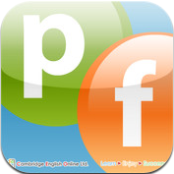[**PHONETICS FOCUS, BY CAMBRIDGE ENGLISH ONLINE**](https://itunes.apple.com/us/app/phonetics-focus/id393109855?mt=8)

This app offers a phonetic typewriter, games, flash cards, audio recording and playback, and other necessities for mastering the language.

[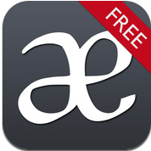](https://itunes.apple.com/us/app/sounds-pronunciation-app-free/id428243918?mt=8)

[**SOUNDS: THE PRONUNCIATION APP**](https://itunes.apple.com/us/app/sounds-pronunciation-app-free/id428243918?mt=8)

The charts included here cover both British and American English, and users tap different sounds to hear them as well as examples in a common vocabulary word.

[](https://itunes.apple.com/us/app/berlitz-my-english-coach-for/id422291447?mt=8)

[**BERLITZ MY ENGLISH COACH FOR IPAD – BY BERLITZ**](https://itunes.apple.com/us/app/berlitz-my-english-coach-for/id422291447?mt=8)

Learn English through vocabulary, sentence structure, phrases and idioms, questions and answers, practice conversations, history and geography lessons, and a little dictionary all meant to beef up their skill sets.