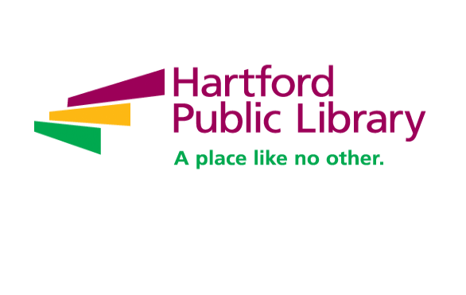**Digital Library Lab Project Manager**

Hartford Public Library is nationally recognized for its wide range of initiatives including immigration services, employment assistance, school partnerships and youth leadership training. Now celebrating its 127th year, Hartford Public Library remains at the forefront of redefining the urban library experience. HPL is the catalyst for opportunities in education, civic engagement, intellectual enrichment and cultural development for tens of thousands of children, youth and adults every year. [www.hplct.org](http://www.hplct.org).

The library seeks a Digital Library Lab Project Manager. In this role you will be responsible for all daily lab operations, workflows and activities to convert a wide range of paper-based and media collections to digital formats from general and special collections; oversees production for concurrent projects, providing quality assurance for all operations, and ensuring standards and best practices are followed; and plays a key role, working with the Library’s Digital Collections Working Group in developing procedures, designing new workflows, and identifying and testing tools and software to increase the Lab’s capabilities to address current and new needs.

* Plans and directs the work of multiple in-house and vendor projects and activities to meet departmental and Library goals and priorities
* Hires, trains, and supervises full-time, student, grant staff, and interns on all activities of materials preparation, image capture, creation and management of master and derivative files, and quality control
* Ensures that digital conversion of paper-based and media materials is accomplished following established standards for creation of digital preservation masters and local guidelines for ingest into preservation repositories and interface systems
* Develops project timelines and ensures annual production goals are met
* Monitors, evaluates and improves workflows and procedures for production efficiency and quality
* Develops and implements a quality assurance program for all Lab operations
* Creates training materials; provides and maintains technical and procedural documentation
* Performs and maintains workflows to share files with external repositories that support expanded access to users
* Provides basic technical support for the Lab’s imaging and processing equipment and software
* Identifies, tests and recommends useful commercial and open source software for image capture and file processing; implements new hardware and software into production workflows
* Develops methods and procedures, and works with digital library partners and developers to automate and improve activities and production workflows
* Incorporates databases, scripts and image processing utilities to enhance workflows
* Keeps abreast of digital initiatives, emerging standards, projects and activities on a regional, national and international level
* Plans and meets annual goals of the Digital Library Lab.
* Monitors and documents use of resources, compiles cost and production data and analyzes statistics for annual reports, budgets and planning purposes
* Compiles digital requirements, and provides cost and production estimates for specialty orders, new projects, and workflows for new services
* Collaborates with other departments and staff that support the complete life cycle for digital collections
* Collaborates with Hartford History Center supervisors on preservation treatment actions for materials in digitization workflows
* Participates as a member of the Library’s Digital Collections Working Group
* Performs other duties as assigned

**Qualifications**

* Bachelor’s Degree required.
* Ability to work with a wide range of digital library and metadata standards and best practices for creating digital objects from a variety of original formats, required
* Thorough knowledge of national standards and best practices for creating digital objects from a variety of paper-based original formats
* Sensitivity to the handling issues of a wide variety of general and special collections library materials
* Strong organizational skills, including the ability to establish priorities and achieve goals
* Demonstrated ability to take initiative and ownership of projects with strong attention to detail and accuracy.
* Excellent written, oral and interpersonal communication skills
* Experience managing a process from design to completion
* Supervisory experience directing technical staff
* Experience writing technical documentation
* Demonstrated expertise and technical knowledge in the creation and management of digital information including image capture, quality control, scanning hardware and software, digital file formats, and compression schemes
* *COVID-19 vaccination required*

**Preferred Experience:**

* MLS degree
* Knowledge of preservation issues in cultural institutions
* Experience managing digital projects in a library, museum or commercial imaging environment
* Experience with digital preservation and curation practices and principles
* Experience using Microsoft Access to pull data from other databases and manipulate it
* Knowledge of a scripting language, such as Python
* Knowledge of color calibration and color management systems
* Knowledge of standards and practices for conversion of media collections
* Knowledge of digital preservation metadata standards and descriptive metadata standards

**To Apply:** Please email resume and cover letters to the attention of the Director of Human Resources at sdwhite@leadingculturesolutions.com and note **“Digital Library Lab Project Mgr”** in the subject line.

Hartford Public Library is an Equal Opportunity Employer.