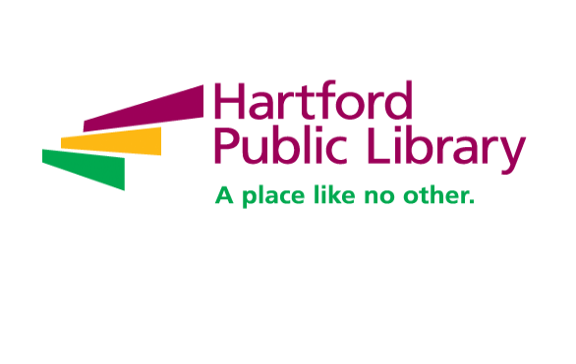

**Immigrant US Citizenship Attainment Specialist**

Hartford Public Library is nationally recognized for its wide range of initiatives including immigration services, employment assistance, school partnerships and youth leadership training. Now celebrating its 127th year, Hartford Public Library remains at the forefront of redefining the urban library experience in the 21st Century with services designed for and by a diverse and dynamic city and region. With seven locations throughout the city, HPL is the catalyst for opportunities in education, civic engagement, intellectual enrichment and cultural development for tens of thousands of children, youth and adults every year. [www.hplct.org](http://www.hplct.org).

The **Immigrant US Citizenship Attainment Specialist** supports Hartford Public Library’s mission and core values and oversees the day-to-day management of the Innovations in Citizenship Education two-year grant-funded project (October 2022 – September 2024). The incumbent manages the work of the USCIS Innovation Project, targeting immigrant youth and their families. Responsibilities include project planning, implementation, development, promotion and extremely robust outreach. This is a demanding position that requires the ability to multi-task and work effectively with diverse populations. This individual will be self-motivated, flexible, persistent, very attentive to detail and able to be an organizer and coordinator of many activities.

**Project Coordination**

* Manages the development and implementation of the project, with oversight of all project activities
* In collaboration with The American Place staff, coordinator and accurately maintain all record keeping, data collection, and financial tracking for the project; this includes maintaining records on participant attendance and progress, outreach efforts and follow-up
* Manages, track, and oversee grand budget and deliverables, ensuring grant deliverables are met within budget parameters
* Coordinates meetings and prepare agendas, minutes and reports
* Supports project evaluations with disturbing surveys and other evaluation tools and collecting results
* Assists with special projects as assigned and other tasks deemed necessary to achieve overall goals and operate successful program
* Adheres to all guidelines related to confidentiality with sensitive personal information

**Outreach, Recruitment and Retention**

* Conducts robust outreach to and recruitment of program participants to meet quarterly grant goals.
* Conducts intake interviews for all new programs participants, and establish and maintain case files with all forms and information from participant entry to exit of program(s)
* Coordinates, cultivates, and sustains productive relationships with program partners, as well as participants
* Identifies, cultivates, and maintains relationships with key community partner agencies
* Identifies and refers participants to other resources and services as needed
* Works closely with Hartford Public Schools’ Division of Academics, Teaching, Learning and Student Supports to further align and formalize the Citizenship Guide’s learning goals and objectives, learning materials, learning tasks, assessments and engagement metrics with HPS’s Capstone, Community Service and Internship Opportunities

**Education and Experience /Qualifications:**

* Minimum of Bachelor Degree in education or related field; Master’s Degree in Education TESOL preferred
* Proven project management expertise to oversee complex projects, track project activities and see activities through to completion
* Excellent communication skills; Spanish proficiency, or other language beyond English, preferred
* Strong interpersonal skills with demonstrated ability to initiate, build, and continuously strength partnerships with a diverse population
* Demonstrated ability to identify, build, and nurture partnerships with key stakeholders
* 2-years educational experience with secondary or post-secondary youth
* Self-motivated, quick study, and able to work effectively with minimum supervision
* Computer literate with proficiency in Microsoft productivity software
* Effective written and verbal communication skills
* Demonstrated ability to work collaboratively with co-workers
* Ability to maintain confidential information
* Available to work a flexible work schedule, including evenings and weekends as required

**To Apply Click Here:** <https://www.indeed.com/job/immigrant-us-citizenship-attainment-specialist-64a3ecc62156b7ef>

Newly hired employees of the Hartford Public Library must present proof of receipt of a COVID-19 vaccination and may not begin employment at the Library until proof of vaccination (two doses of either the Pfizer or Moderna vaccines or one dose of the Johnson & Johnson vaccine). Booster vaccinations may be required in the future. The Library may consider exemptions for prospective employees who cannot become vaccinated due to a qualifying medical condition or a sincerely held religious belief. Candidates who receive a conditional offer of employment and who seek a medical or religious exemption to the Library’s vaccination policy will be provided with additional instructions at the time of the conditional offer. Testing requirements and/or additional PPE requirements may apply to unvaccinated employees.

**Hiring Range:** $57,391.10 - $64,143.04 DOE

**Hartford Public Library is an Equal Opportunity Employer.**