**CONTACT:**

Donna Larcen

Interim Communications 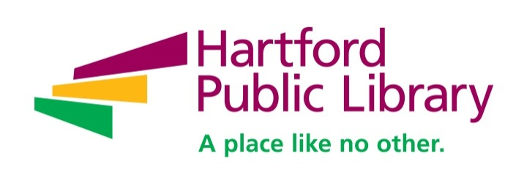Specialist

Cell: 860-692-8955

[dlarcen@hplct.org](mailto:dlarcen@hplct.org)

**For Immediate Release**

**BABY GRAND JAZZ SERIES CONTINUES**

**Hartford, March 1, 2016 –** The 13th Annual Baby Grand Jazz Series, sponsored by The Charles H. Kaman Charitable Foundation, continues through April 24. The free, hour-long concerts are run Sundays, 3 pm, in The Atrium on the ground floor.

The concerts are presented in partnership with the Hartford Jazz Society and WWUH 91.3 FM.

The remaining schedule: March 6, the Lenore Raphael Duo performs with Raphael on piano and Wayne Wilkinson on guitar; March 13 is the Jonathan Ball Quintet, with Hartford’s Ball on saxophone, Matthew Finck on guitar, Jeff Homes on piano, Jay Anderson on bass, and Tony Jefferson on drums; March 20 brings the reschedule Ayako Higuchi concert at 2 pm, followed by The Colbys with John Colby on keyboards and vocals and Bev Rohlehr on vocals.

Also, on April 3 the Ray González Jazz Quartet with González on trumpet, Damian Curtis on piano, Miguel Rios on percussion, Benny Velazquez on bass and Tony Gonzalez on percussion; April 10, Sambeleza with Isabella Mendes on piano, Joe Carter on guitar, and Jeff Fuller on bass and vocals; April 17, TRIchrO (formerly East West Trio), with Eriko Yamaki Mercure on piano, Mark Fairweather on drums, and David Mecure on bass: and April 24, Hartford’s own Emery A. Smith on piano.

It’s the final week to see the photography “Expressions in Sounds and Motion,” by Maurice Robertson, on display in the ArtWalk gallery on the third floor. Robertson explores the meditative qualities and the outward, flowing dynamism of jazz musicians at play. The exhibit ends March 4, 2016 and can be visited during regular Library hours.

**ABOUT HARTFORD PUBLIC LIBRARY**

As a finalist for the 2013 and 2014 National Medal from the Institute for Museum and Library Services, Hartford Public Library has been recognized as national leader in redefining the urban public library in the 21st century as an innovative and stimulating place where people can learn and discover, explore their passions and find a rich array of resources that contribute to a full life. Hartford Public Library provides free resources that inspire

reading, guide learning, and encourage individual exploration. Serving the residents of Hartford and beyond at its nine branches and Downtown location, Hartford Public Library receives more than 833,000 visits per year from adults, children and families seeking early literacy opportunities, work skills training, civic engagement, arts enrichment, and so much more. Please visit www.hplct.org.

**Hartford Public Library/500 Main St./Hartford CT 06103**