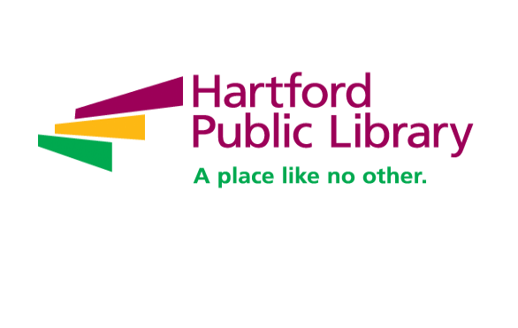

**Library Assistant –Park Branch Part-Time (Bilingual Preferred)**

The Library Assistant performs customer service assistance in person, by phone, and via email, and provides instruction on the use of library facilities, equipment, and technology. Duties include using electronic library systems to perform clerical services, including circulation of library materials, updating records, and communication with patrons and library staff; collection development and maintenance; and assisting with other library projects and programming. This position requires a great deal of public contact, excellent customer service skills, demonstrated patience and empathy, and an ability to keep abreast of library events, services, and procedures. Responsibilities include:

**Greeting and Customer Service**

* Greet and welcome customers, in person and on the phone; answer customer inquiries via email
* Addresses inquiries and connect customers to the correct service or staff person
* Responds to questions and complaints related to library use and/or refers customers to supervisor for more detailed information/assistance.
* Uses traditional library resources including the library website, library catalogue, booklists, ready reference resources, etc., to answer routine, quick reference and straightforward customer inquiries including, but not limited to basic readers’ advisory (ex. specific book titles)

**Technical Assistance**

* Use electronic library systems to perform clerical services, including circulation of library materials, updating records, and communication with patrons and library staff
* Assists customers in using the online catalog, Internet, library databases, website, and other electronic resources
* Assists customers in use of printers, fax/scan machines, and other commonly accessible technology equipment

**Processing of Customer Accounts and Circulation of Materials**

* Assists customers in borrowing, renewal and returning books and other materials
* Processes library card applications; updates customer accounts
* Collects payment for services, damaged or lost books and materials

**Shelving and Collection Maintenance**

* Perform stacks and materials maintenance; sort and shelve books and other materials.
* Prepares new library materials; helps maintain material displays; and assist with other library projects

**Library Service Delivery and Promotion**

* Performs direct services to customers (Municipal ID, notary public, or passport services)
* Engages customers with a focus on supporting their needs, delivering high quality services, and connecting them to the collection and library services
* Assists with ongoing or temporary projects (ILS records maintenance, stacks signage, Etc.)

**QUALIFICATIONS:**

**Required**

* High School Diploma or equivalent
* One year of customer service experience
* Ability to work in a fast-paced environment. Experience working with diverse populations. Community service.
* Able to travel to all library locations (across Hartford).
* Bilingual communication (oral and written).

**Preferred**

* Bachelor degree in related field

# What we offer employees:

Hartford Public Library offers part-time benefits you won’t find at other nonprofit organizations through a unique partnership with the City of Hartford. This includes:

* Paid vacation time - prorated based on part-time status. Example: Average 25-hour work week will accrue approximately 1.9 hours per pay period.
* Paid sick time – prorated based on part-time status. Example: Average 25-hour work week will accrue approximately 2.9 hours per pay period.
* Mental health support through the Employee Assistance Program (EAP)- first 3 sessions at no cost to the employee.
* Paid professional development, continuing education and staff engagement opportunities.
* Commitment to, and active plan of, diversity, equity, and inclusion work including implementation of a staff-led DEI Road Map.

**What we offer the community:**

The Hartford Public Library is a national leader in redefining urban public libraries in the 21st century as innovative, stimulating and engaging spaces where people can learn and discover, explore their passions and find a rich array of resources that contribute to a full life.

We are an integral part of the Hartford community and offer programs for all our citizens. With 7 locations and robust outreach services, we are here for Hartford. Our programs include:

* The American Place, which offers a variety of free services to welcome immigrants and refugees including English Language Learning, Citizenship preparation and civic engagement
* Digital Library Lab
* Hartford History Center
* HPL Studios
* YOUmedia teen spaces
* Baby Grand Jazz, a free series of Jazz performances open to everyone
* Summer Learning
* Leap into Learning - Early Literacy
* Adult education classes and support
* Career Certification, GED
* Technology training and digital literacy
* Library of Things
* Robust print, electronic, audio and video collections

**To Apply:** Please email resume and cover letter to hpljobs@hplct.org and reference **Library Assistant Park Branch** in the subject line of your email. Resumes will only be accepted by email.

In light of the ongoing COVID-19 pandemic, the Hartford Public Library strongly recommends and encourages all employees to receive vaccinations. Vaccinations have proven to be an effective measure in preventing the spread of the virus and protecting individuals from severe illness. We are committed to safeguarding our workplace and community. While COVID-19 vaccinations are recommended, vaccinations are not required at this time.

**Salary:** $19.91 hourly – Per CBA

**Hartford Public Library is an Equal Opportunity Employer.**