

**Contact: Andy Hart**

**Hartford Public Library**

**860-695-6282**

**ahart@hplct.org**

**Hartford Public Library Launches New App**

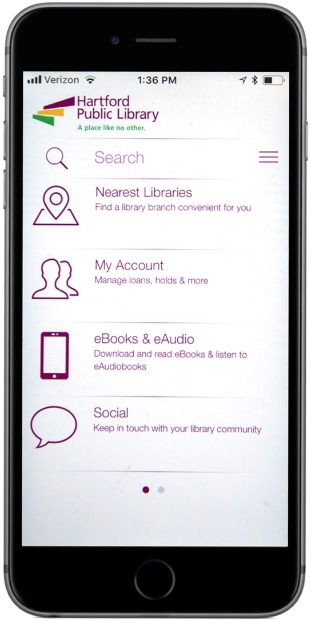**(HARTFORD, CT: December 12, 2018)** Now Hartford Public Library is as close as your phone. The new Hartford Public Library (HPL) App can now be downloaded for free from the iPhone App Store or the Google Play Store.

With the new HPL App, you can check your account, renew items, and more. You can also find the nearest library branch and check whether it’s open.

The HPL App also allows you to download a wide variety of e-books, audio books and other materials with just a few taps on the screen.

You can also use the new HPL App to check the library’s Facebook and Twitter accounts and to read the weekly New Book Blog.

**ABOUT HARTFORD PUBLIC LIBRARY**

Now celebrating its 125th year, Hartford Public Library remains at the forefront of redefining the urban library experience in the 21st Century. With seven locations throughout the city, the library provides education, intellectual enrichment and cultural development for thousands of children, youth and adults every year. Hartford Public Library has also gained local and national recognition for its wide range of new initiatives and partnerships designed to meet the needs of a diverse and dynamic city and region, including immigration services, employment assistance and youth leadership training. Please visit www.hplct.org.