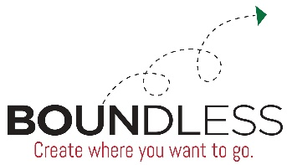
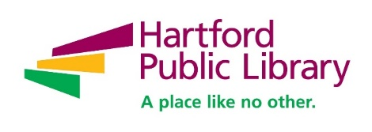
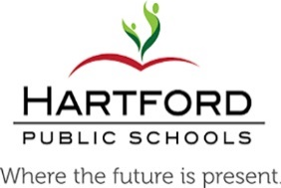

Contact: Mary Coursey
Coursey & Company
860-305-0476
mary@courseyco.com
FOR IMMEDIATE RELEASE

Hartford Public Library and Hartford Public Schools Launches Boundless Pilot Program at Rawson School
(HARTFORD, CT, January 25, 2019) Today at Sarah J. Rawson Elementary School, Hartford Public Library (HPL) CEO Bridget Quinn-Carey and Hartford Public Schools (HPS) Superintendent Dr. Leslie Torres-Rodriguez joined state and local officials, Blue Hills neighborhood community members, and Mr. Cobb’s 3rd grade class to officially launch the Boundless partnership and the Boundless library at Rawson School.
This unique collaboration means that students at Sarah J. Rawson Elementary School in Hartford’s Blue Hills neighborhood are now fully interconnected with the Hartford Public Library (HPL) and its vast wealth of learning resources. The Boundless Library at Rawson will provide students with a wide range of resources and assistance designed to improve the learning experience, increase literacy rates and better prepare students for high school, college, employment and beyond. This new influx of educational resources will also be available to Rawson parents, teachers and the community as a whole in order to develop a neighborhood of learners and teachers.
“Providing access to learning for the broadest scope of people possible was the original genesis of Hartford Public Library itself, and it remains at the very core of our mission. The seamless integration of library and school that we are starting with the school system at Rawson will open up a vast array of educational opportunities for students and targeted assistance for teachers. In addition, the Boundless Library will become the focal point for the increased intellectual enrichment of the surrounding community,” said Quinn-Carey.
Superintendent Torres-Rodriguez said: “We are thankful to our partners-in-learning at the Hartford Public Library for working beside us, shoulder-to-shoulder, to increase educational access for our beautiful and capable students. Boundless provides greater access to paper books and digital resources to help our students develop that crucial, life-long love of reading. When I was a child, the Park Street public library branch was my second home. It was my love of reading that helped to secure my future.One of our major goals is to make all schools community schools; this gets us closer to our goal. Boundless benefits our students, teachers, families, and the entire school community. And it profoundly supports our literacy goals which we know are key to student success. Supported by a Media Specialist, this is a traditional library where the past and future meet; combining all the tools our students need to thrive in the 21st century. We are excited about the tremendous benefits this partnership is bringing to Rawson School and we hope that this pilot program will be implemented at more schools in the future.”
Vanessa Diaz-Valencia, Hartford Public Schools Assistant Director of Curriculum, Instruction & Programs, is also excited about this new step in the Boundless Partnership. “The partnership and programming between Hartford Public Schools and the Hartford Public Library is a long standing relationship. However, Boundless is an effort to further deepen the connection between schools and libraries for our teachers, students, and community,” she said. “Libraries are a place where students can truly unlock their imaginations and aspirations through books.”
HPL has assigned a Boundless Librarian/Media Specialist to Rawson who will work closely with school teachers, staff, students and families to identify ways in which the library’s resources can best support and assist the school and the community. One of the key reasons for selecting Rawson was that the school’s physical layout is highly conducive to after-school and summer use by students and residents.
“This creative partnership between our library and our school system will dramatically expand the teaching and learning resources available to students and parents. Boundless can have a meaningful impact on performance - but even more importantly, it can help inspire and encourage a love of learning in Hartford kids. Superintendent Torres-Rodriguez and Bridget Quinn-Carey and their teams have done a terrific job putting Boundless together and I am excited about this partnership,” said Hartford Mayor Luke Bronin.
Hartford City Council President Glendowlyn Thames said, “I applaud the leadership of the Hartford Public Library and Hartford Public Schools for enhancing their partnership and making this happen for the Blue Hills community. Schools are our biggest community asset and this is a prime example of how we can leverage resources to provide optimal learning opportunities for the community at large.”
Since being launched in 2015, Boundless has provided after-school and summer programs, field trips, homework assistance and increased digital accessibility at several Hartford schools. From April through May of this year, 3,449 children and adults attended 117 Boundless programs held throughout the school system. At the Parkville, McDonough and Maria Sanchez Schools alone, library cards have been distributed to over 3,000 students.
“The reaction to Boundless from students, teachers and parents has been highly encouraging,” said Quinn-Carey. “Making the library a daily presence in the schools is the next logical step. The Boundless Library at Rawson will add a whole new dimension to learning for students, teachers and families, and I believe the success of this pilot program will promote its extension to numerous other Hartford schools. Our partnership with the school system is continuing to blossom as we explore new avenues of cooperation and work together on shared goals.”
“The Blue Hills Civic Association is proud to be associated with our partner, Rawson Elementary School for the Hartford Public Library / Hartford Public School’s Boundless Program. Through the power of advocacy - by working with concerned residents and collaborating with city officials (political, education and library) it has led us to this exciting moment. Although we do not have a full-service library at this point, this is a great start and a victory for the entire Blue Hills neighborhood – parents, children, families and teachers,” said Victoria Fennell, Chair of the Blue Hills Civic Association.
Rawson Boundless Library is now open to support students and teachers during the school day. Additionally, beginning February 5, it will be open to the public on Tuesday and Thursday from 3:30 -6:00 p.m. until June. Summer hours will be confirmed at a later date. For more information on Boundless visit the website: http://www.boundlesshartford.org.
Funding for the Boundless Library at Rawson has been provided by The Hartford, Travelers, the J. Walton Bissell Foundation, and through in-kind support from Hartford Public Library and Hartford Public Schools.
ABOUT HARTFORD PUBLIC LIBRARY
Now celebrating its 125th year, Hartford Public Library remains at the forefront of redefining the urban library experience in the 21st Century. With seven locations throughout the city, the library provides education, intellectual enrichment and cultural development for thousands of children, youth and adults every year. Hartford Public Library has also gained local and national recognition for its wide range of new initiatives and partnerships designed to meet the needs of a diverse and dynamic city and region, including immigration services, employment assistance and youth leadership training. Please visit www.hplct.org.

# # #

