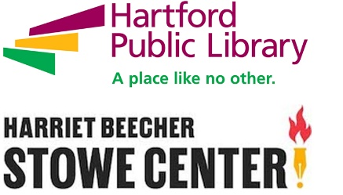

**Contact: Andy Hart**

**Hartford Public Library**

**860-695-6282**

**ahart@hplct.org**

**Yale History Professor to Discuss Intriguing New Book on *Connecticut Circle* Magazine at Hartford Public Library**

**(HARTFORD, CT: February 19, 2018)** Yale History Professor Jay Gitlin, editor of *Country Acres and Cul-De-Sacs: Connecticut Circle Reimagines The Nutmeg State, 1938-1952*, will discuss the new book in a special talk on Saturday, March 9, at Hartford Public Library’s Hartford History Center, 500 Main Street, Hartford, from 2-4 pm. The talk is being held in partnership with the Harriet Beecher Stowe Center. *Country Acres and Cul-De-Sacs* was published by the Nutmeg Club, an organization devoted to promoting Connecticut history. Several club members contributed essays to the book.

*Country Acres and Cul-De-Sacs* is largely composed of reprinted articles from *Connecticut Circle,* a magazine which was published from 1938-1970 (and later developed into *Connecticut Magazine*). However, Gitlin said he decided toconcentrate on the magazine’s first 14 years, “not only because it featured many significant events, but also because, in this editor’s opinion, the magazine was at its best in its first decade and a half.”

*Country Acres and Cul-De-Sacs* certainly does contain intriguing accounts from *Connecticut Circle* of major events, including the destruction wrought by the 1938 Hurricane (“Your permanent record of 24 ghastly hours”) and the opening of the Merritt Parkway. Other articles have increased in interest with the passage of time, such as “Proposed Cure for Hartford Traffic,” which lays out the route of I-84 several years before it was built.

Gitlin, an authority on the suburbanization of America, is also fascinated by *Connecticut Circle’s* efforts to promote Connecticut as the perfect escape for world-weary city folk, especially those from New York City. This rebranding of the state as a bucolic wonderland steeped in its colonial past was often at odds with the reality of a Connecticut which had become a highly commercialized and increasingly diverse industrial powerhouse by the time *Connecticut Circle* began in 1938.

Gitlin’s talk on March 9 is free and open to the public. Copies of *Country Acres and Cul-De-Sacs* will be available for sale.

**ABOUT HARTFORD PUBLIC LIBRARY**

Now celebrating its 125th year, Hartford Public Library remains at the forefront of redefining the urban library experience in the 21st Century. With seven locations throughout the city, the library provides education, intellectual enrichment and cultural development for thousands of children, youth and adults every year. Hartford Public Library has also gained local and national recognition for its wide range of new initiatives and partnerships designed to meet the needs of a diverse and dynamic city and region, including immigration services, employment assistance and youth leadership training. Please visit www.hplct.org.

**ABOUT THE HARRIET BEECHER STOWE CENTER**

The Harriet Beecher Stowe Center, a museum, program center and research library, is located at 77 Forest Street in Hartford, CT. The Stowe Center is open year round for tours and programs. The Harriet Beecher Stowe Center uses Stowe's story to inspire commitment to social justice and positive change. For the most up to date information, follow on Twitter <http://bit.ly/1qpOzCQ>.